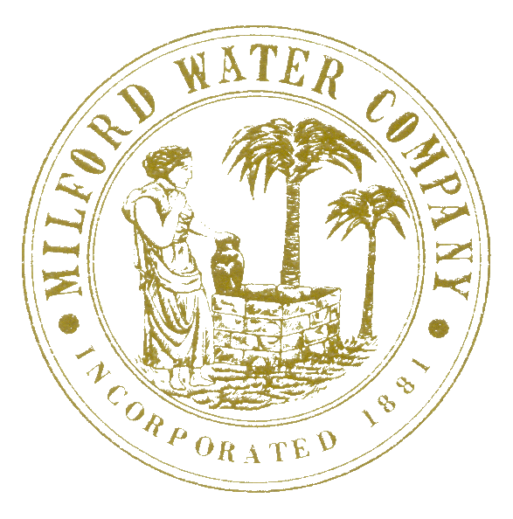

Effective July 1st 2018

Milford Water Company is on a STAGE II Water CONSERVATION Level.

What does this mean to you as a customer?
ALL OUTSIDE WATER USAGE INCLUDING IRRIGATION WATER IS LIMITED TO AN ODD – EVEN ALLOCATION PROGRAM BETWEEN THE HOURS OF 7PM AND 7AM. This means that all outside water use is based on your house number, odd numbers may use water on odd calendar days and even numbers may use water on even number days after 7pm and before 7am.
MWC DOES MONITOR FOR VIOLATORS OF THE CONSERVATION STAGES.
The Milford Water Company at this time would like to thank all of its customers for their cooperation in this matter and hope that by CONSERVING now we will not need to increase our water restriction going forward.
Should you have any questions or concerns please do not hesitate to call. Information on the current Stage Level may also be found on the company’s web page www.milfordwater.com.

Respectfully,
David L. Condrey, Manager Milford Water Company

